GUÍA DE AUTOEVALUACIÓN DE UNIDAD 1 “HOME TIME”
Guía n° 5 English Language

Nombre: |  | Curso: | 6th | Fecha

INSTRUCCIONES:
- Cuenta con 5 días para responder la guía.
- No se podrá entregar la guía sin estar resuelta completamente.
- La guía puede ser resuelta con apoyo de un diccionario y sus cuadernos de ser necesario. No está permitido copiar trabajos de otros compañeros/as.
- Utilizar lápiz pasta azul o negro.
- LA GUÍA DEBE SER ENVIADA EL DÍA VIERNES 05 DE JUNIO HASTA LAS 16 HRS. Al correo:
- Pamela.roky@elar.cl
- Esta guía no lleva nota

Objetivos: Demostrar conocimiento sobre el uso del presente simple y vocabulario temático.
Contenidos: Presente simple en su forma afirmativa, negativa e interrogativa y verbos para la tercera persona singular y vocabulario sobre actividades de rutina diaria.

ITEM I.- Choose the correct alternative for each sentence below. Please! Read carefully before choosing your alternative. Remember! This content is about Present Simple in Affirmative and Negative form.

- She ______________ her room.  - Clean  - Cleaning  - Cleans  - To clean | - We _____________ in the garden.  - Playing  - To play  - Play  - Plays
- I ___________ have lunch.  - Not do  - Don’t  - Doesn’t  - Not does | - He __________ work at the hospital.  - Don’t  - Not do  - Doesn’t  - Not does

ITEM II.- Choose the correct alternative for each sentence below. Please! Read carefully before choosing your alternative. Remember! This content is about Present Continuous in Affirmative and Negative form.

- The baby _____ _____________ right now.  a) Laugh  b) am laugh  c) is laughing  d) to laugh | - We ____ __________ pizza now.  a) is eat  b) are eating  c) am eat  d) are eat
- Kate and John ___ ___ ____________ TV.  a) not watch  b) is not watch  c) are not watch  d) are not watching | - He ___ ___ _______________ this night.  a) is not walking  b) are not walk  c) not walk  d) is walk

ITEM III.- Choose the correct alternative by looking at the pictures below. Remember! This vocabulary is related to fruits, vegetable, nuts and other kinds of food.

- Do my homework  - Have breakfast  - Cook  - Wake up |  | 12)  a) Have a lunch  b) Brush my hair  c) Do my homework  d) Take a nap | 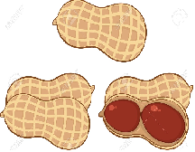
13)  a) Get up  b) Ride my bike  c) Go to work  d) Do my homework | 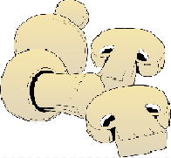 | 14)  a) Watch TV  b) Brush my teeth  c) Study  d) Drink | 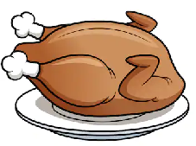
15)  a) Wake up  b) Read  c) Take the bus  d) Go to sleep | 